==

**Multiplier Events**

**Accounts from:**

**Ortona**

**Znanie**

**SEERC**

**Lodz**

**UK**

**2015-2017**

­

**Ortona**Held in the imposing music library in Ortona, the Helpcare team made an impact across the region thanks to the large audience of civic leaders, social workers, carers and care users in attendance. To spread the message further, Dr Carolyn Downs was interviewed by the attending TV crew regarding the importance of the project to ensure the quality of life for the vulnerable. Special thanks must go to the Mayor of Ortona, and the head of social services that made poignant presentations about the necessity of care work.

Over 50 people attended the event in Ortona including care workers, elderly care users, policy makers and social workers.

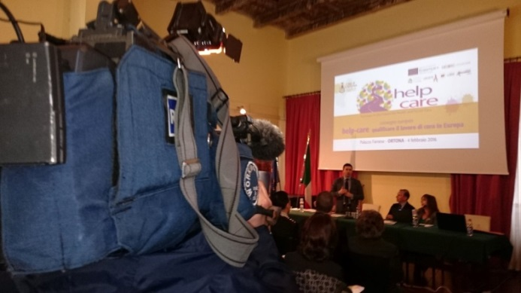

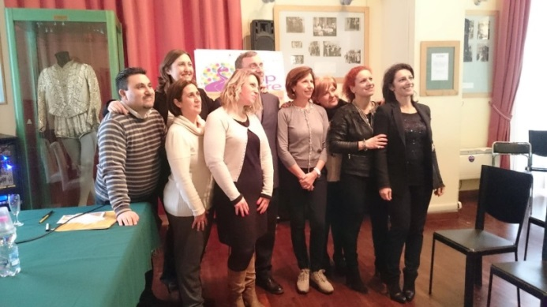



**SEERC**The HelpCare project is an Erasmus+ funded project that the Faculty’s research centre, the South East European Research Centre ([SEERC](http://www.seerc.org/)) joined as a research partner in 2016. The main objective was to identify the training needs and the condition that can lead to the “professionalization” of long term care, namely the delivery of care in high quality from formal or informal caregivers. [Mr Pavlidis](http://citycollege.sheffield.eu/frontend/members_profile.php?m=43), Lecturer at the [Psychology Department](http://citycollege.sheffield.eu/frontend/articles.php?cid=92&t=Psychology) of the International Faculty of the University of Sheffield, CITY College, and researcher in SEERC, presented to 30 commissioners of care deriving from various parts of Greece the research findings of the project, as well as analyzed the use of several guides and tools that were developed to train formal and informal caregivers in providing care effectively and with more confidence.

**www.helpcare-project.org**

**George Pavlidis** stated:“This event was an excellent opportunity to present the findings and the outputs of the HelpCare project, as well as to receive feedback, comments, and valuable insight for the challenges that care providers face in their efforts to provide care in high quality in Greece. The event produced interesting discussion and strengthened a network that is committed to the delivery of care in professional standards.”

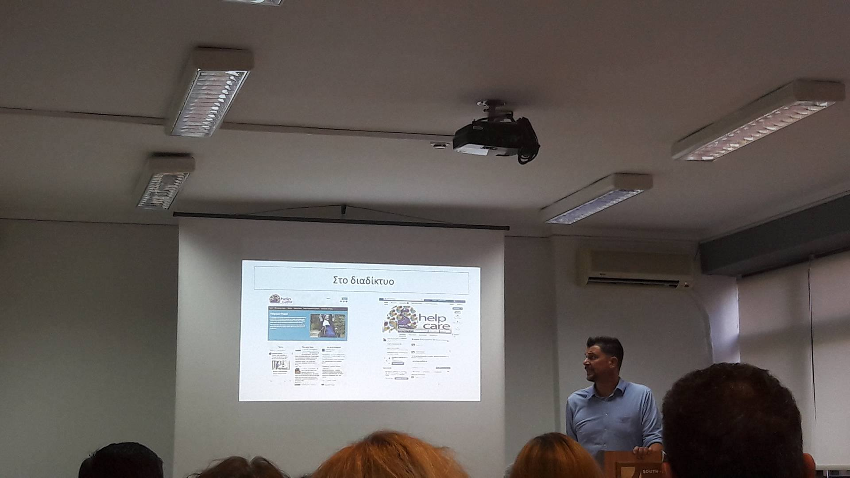

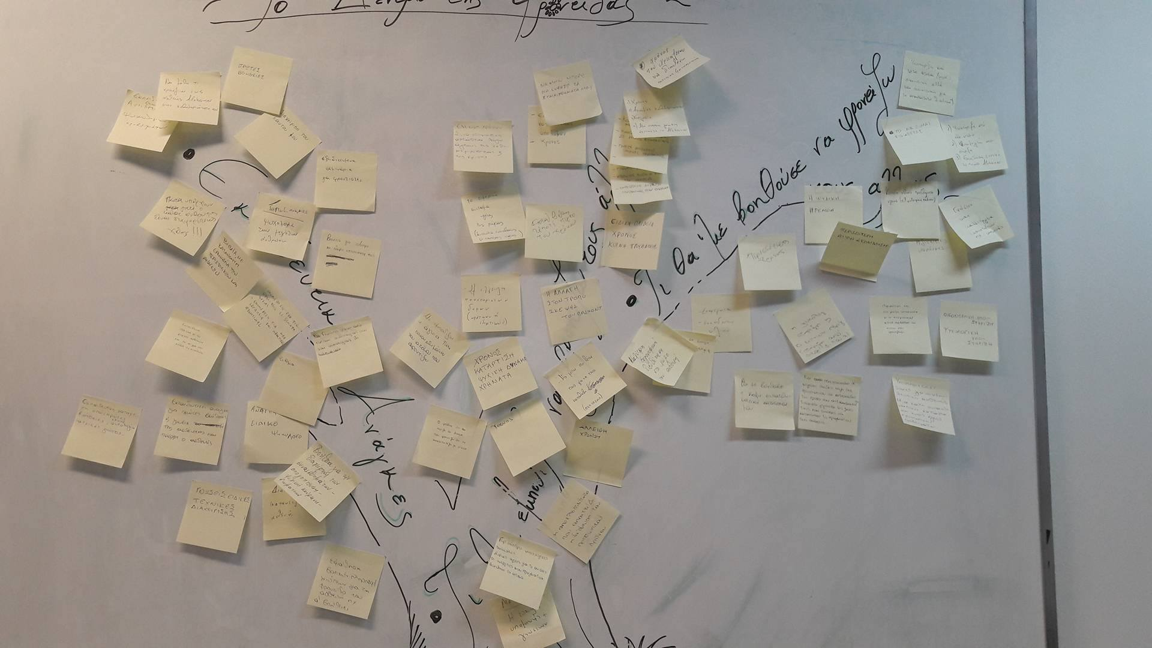



**www.helpcare-project.org**

**Znanie**   
**Sofia, Bulgaria Meeting & Multiplier Event**

***Working with policy makers and frontline care staff***

The multiplier event in Sofia took place at 14th of September in hotel City Avenue. Partners presented the concept of the project, the findings from the survey conducted amongst care workers, informal carers, co-researchers and care users, and the next steps related to development of the CPD training modules for carers

The event was very well attended by representatives from different local and governmental institutions (Employment Agency, Agency for Social Support, Ministry of Labour and Social Policy), and also representatives from Sofia University, Centers for Vocational Training and state and private homes for elderly people.



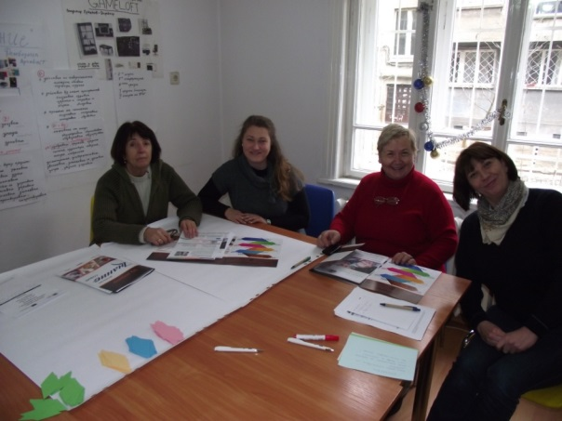

The Helpcare project partners very much appreciated the invaluable participation of the group from *Simitly who* represented people from different areas of care: care workers, occupational therapists, social assistants and who were involved in the survey phase and collection of primary data related to the project and shared valuable information.

Both during the presentation and the interactive part of the session, participants took an active part expressing their views, interests, support and opinions on how the project should progress to in the next phase.

Enthusiastic requests for access to the final product i.e. CPD training modules, were received by several organisations who attended the event. The event & project generated a lot of interest!

Lorem ipsum dolor sit amet, consectetur adipiscing elit. Nam elementum arcu libero, at viverra ipsum imperdiet et. Mauris consectetur, neque sed consequat mollis, augue arcu accumsan neque, a rhoncus quam enim et nisl. Donec rhoncus erat non congue vulputate. Quisque turpis dui, pretium luctus.



**In 2016** there were 12 social care homes in Lodz for old people, including 11 houses run by the City of Lodz and 1 house managed by the non-public entity (population of Lodz is 700 000). There were 1759 people in these houses (public care homes - 1643, non-public – 116.). Total number of people waiting for a place in a care homes amounted 780 people.

At the end of the meeting, participants were invited to the discussion. Expressed opinions indicated a large variety of experience and practices in social and health care for elderly, however, everyone pointed out that the problem in Poland must be treated as a priority and that the needed actions should be systematic and based on a deep analysis of the situation and the solutions taken in the EU.

**Lodz**  
Dr Katarzyna Roszak, Social Work Specialist from the Department of Coordination and Surveillance of Municipal Social Welfare Center in Lodz presented data on the participation of the Municipal Social Welfare Center in Lodz in supplying services to the elderly. In her speech she indicated that in Poland 14.2% of the population are persons over 65 years of age. On a national scale, the share of this age group in different voivodships is different, with the highest number of people over 60+ living in four voivodships (provinces): Swietokrzyskie, Slaskie, Dolnoslaskie and Lodzkie. The proportion of the population aged 60 and over in the population of the city of Lodz in 2015 was 46.1%.

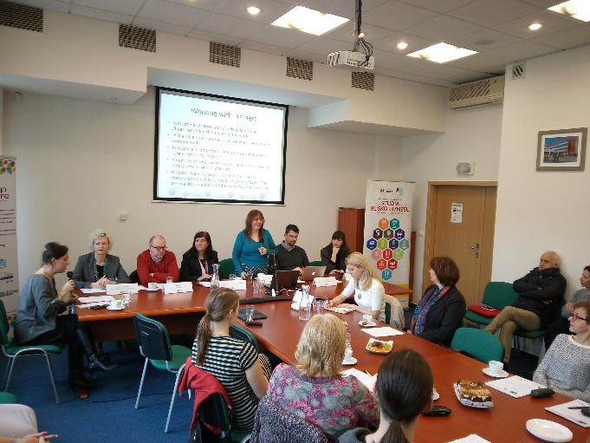 =

**www.helpcare-project.org**



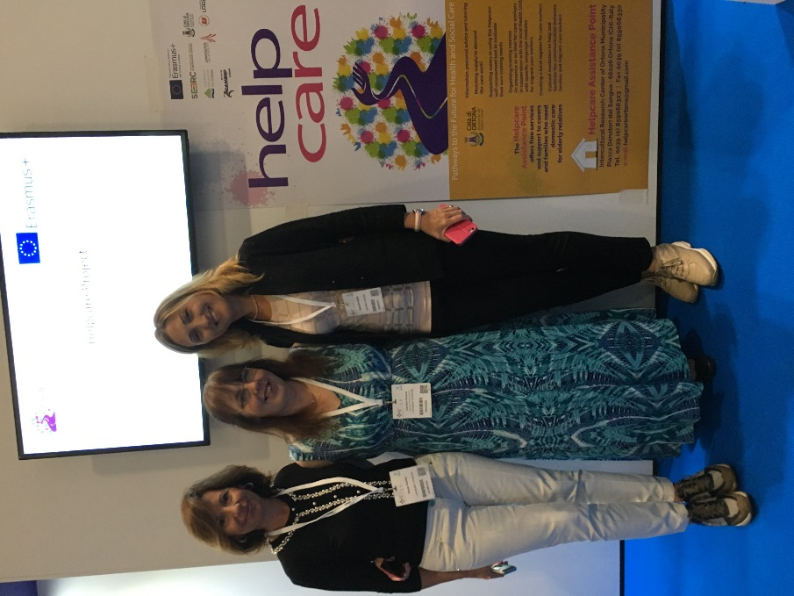**London Training and Professionalization of Care Workers across Europe Event**

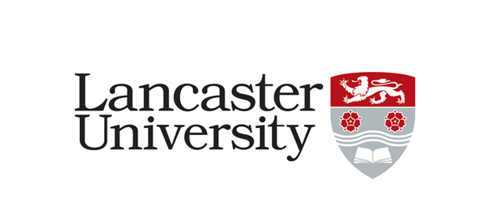

This project has been funded with support from the European Commission. This publication [communication] reflects the views only of the author, and the Commission cannot be held responsible for any use which may be made of   
the information contained therein.

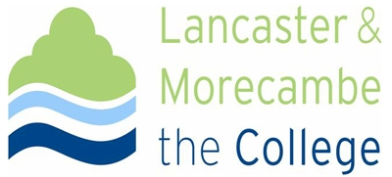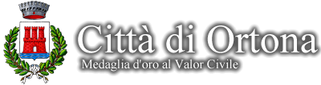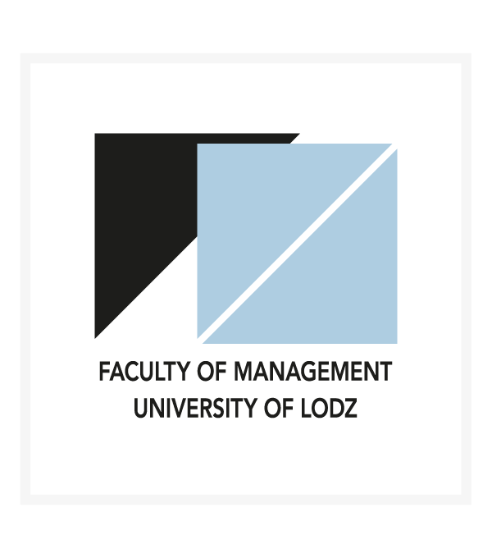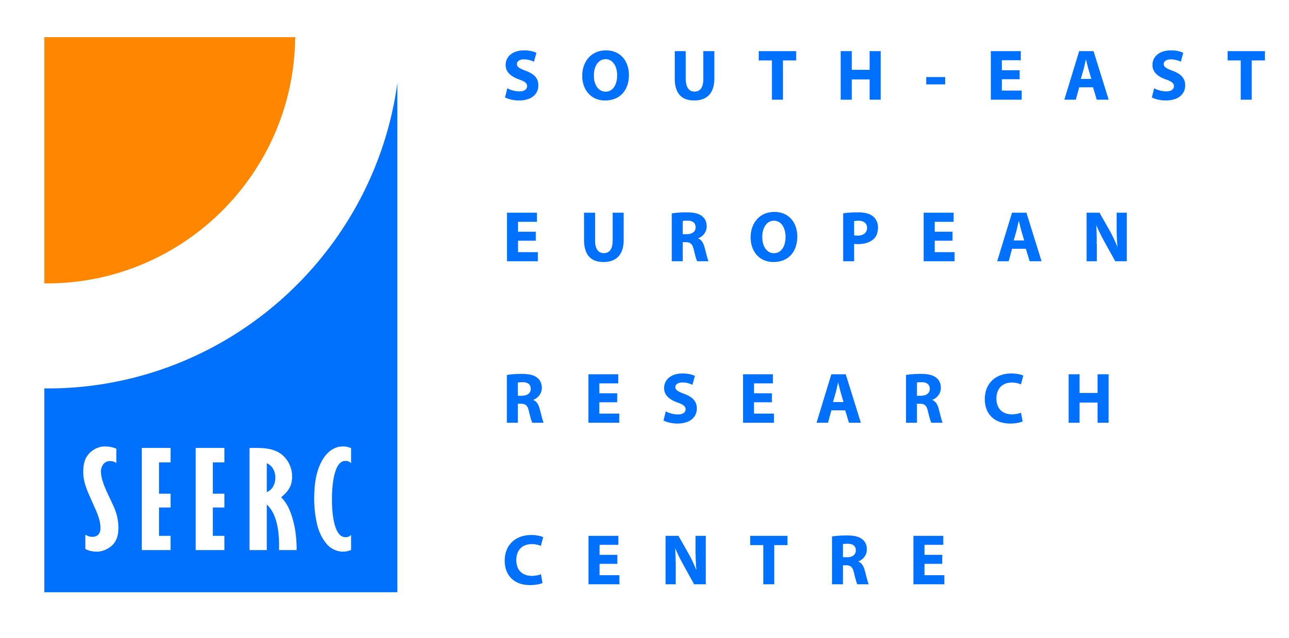

The launch of the *Helpcare Training and Professionalization of Care Workers across Europe* event within the Health +Care conference and exhibition was a tremendous experience for the project team. We directly engaged with over 200 delegates and were able to disseminate our findings, share knowledge and learn from each other.

